Development Application
DA number | SPP-18-01547 | Date of lodgement | 10 August 2018
Applicant | Poly Australia c/- Mecone
Owner | Cudgegong 048 Services Pty Ltd
Proposed development | Demolition of existing structures and construction of a multi dwelling housing development comprising 91 x 3 storey dwellings, strata subdivision and associated car parking, landscaping and drainage works
Street address | Lots 1 & 2 DP 1241790 Macquarie Road, Rouse Hill  (originally Lot 82 DP 208203)
Notification period | 5 to 19 September 2018 | Number of submissions |  | 0 during exhibition periods, but 1 late submission

Assessment
Panel criteria  Section 7, SEPP  (State and Regional Development) 2011 | Capital investment value (CIV) over $30 Million (DA has CIV of $45,769,434)
Relevant section 4.15(1)(a) matters | Sydney Regional Environmental Plan No. 20 – Hawkesbury-Nepean River  State Environmental Planning Policy (State and Regional Development) 2011  State Environmental Planning Policy No. 55 – Remediation of Land  State Environmental Planning Policy (Building Sustainability Index: BASIX) 2004  State Environmental Planning Policy (Sydney Region Growth Centres) 2006  Central City District Plan 2018  Blacktown City Council Growth Centre Precincts Development Control Plan 2018
Report prepared by | Kelly Coyne, Assistant Team Leader Development
Report date | 4 December 2019
Recommendation | Approve, subject to the conditions listed in attachment 8.

Attachments
- Location map
- Aerial image
- Zoning extract, height of buildings map extract and Indicative Layout Plan road pattern
- Detailed information about proposal and DA submission material
- Development Application plans
- Assessment against planning controls
- Clause 4.6 variation – assessment of Applicant’s request
- Draft conditions of consent

Checklist
Summary of section 4.15 matters  Have all recommendations in relation to relevant section 4.15 matters been summarised in the Executive summary of the Assessment report? | Yes
Legislative clauses requiring consent authority satisfaction  Have relevant clauses in all applicable environmental planning instruments, where the consent authority must be satisfied about a particular matter, been listed and relevant recommendations summarised in the Executive summary of the Assessment report? | Yes
Clause 4.6 Exceptions to development standards  If a written request for a contravention to a development standard (Clause 4.6 of the LEP) has been received, has it been attached to the Assessment report? | Yes
Special Infrastructure Contributions  Does the DA require Special Infrastructure Contributions conditions (section 7.24)? | Yes
Conditions  Have draft conditions been provided to the Applicant for comment? | Yes
Contents
1 Executive summary 4
2 Location 4
3 Site description 4
4 Background 5
5 The proposal 6
6 Assessment against planning controls 6
7 Key issues 6
8 Issues raised by the public 10
9 External referrals 11
10 Internal referrals 12
11 Conclusion 12
12 Recommendation 12

Executive summary

The key issues that need to be considered by the Panel in respect of this application are:
- The proposed buildings exceed the maximum permitted building height.
- The proposal has a very minor inconsistency with the Area 20 Precinct Indicative Layout Plan for new public roads.
- Dwelling density requirements.
- Suitability of adaptable housing.
- The Applicant seeks a variation to the minimum required building front setbacks to the corner dwellings.
- The Applicant seeks the removal of the majority of the trees on the site.
- The electromagnetic fields impacts from the existing power lines on the proposed residential development.
- NSW Rural Fire Service requires a Section 88B restriction to be placed on the adjoining property for the purpose of an asset protection zone.

Assessment of the application against the relevant planning framework and consideration of matters by our technical departments has not identified any issues of concern that cannot be dealt with by conditions of consent.

The application is therefore assessed as satisfactory when evaluated against section 4.15 of the Environmental Planning and Assessment Act 1979.

Assessment of the application has also been undertaken in line with Clause 7 of State Environmental Planning Policy No. 55 (Remediation of Land) and we are satisfied that the site can be made suitable for residential development, subject to conditions.

This report recommends that the Panel approve the application subject to the recommended conditions listed in attachment 8.

Location

The site is located in the suburb of Rouse Hill approximately 1 km from Tallawong Metro Station and approximately 2 km from the Rouse Hill Town Centre. The location of the site is shown at attachment 1.

Adjoining the site to the north is 129 Cudgegong Road, which is rural in nature and contains a dwelling and outbuildings with a large amount of vegetation. This site is zoned RU4 Primary Production land and forms part of the Riverstone East Precinct.

To the east is RE1 Public Recreation land that contains electricity transmission lines and an associated easement.

The site is bordered by R3 Medium Density Residential land to the south and west.

The site is located in the Area 20 Precinct of the North West Growth Area.

Site description

The site is legally identified as Lots 1 and 2 in DP 1241790, Macquarie Road, Rouse Hill.

Lot 1 is an irregular shape and has an area of 1.656 ha with a frontage of 135 m to Macquarie Road.

Lot 2 has an irregular shape and has an area of 457 m², with a frontage to Cudgegong Road.

The site currently falls from the north-east corner of the site (approximate RL 70) to the south-west corner of the site at the Macquarie Road street frontage (approximate RL 62).

The site is largely vegetated with Cumberland Plain Woodland and is located wholly within a biodiversity certified area.

The site contains a single storey dwelling, outbuildings and a telecommunications tower.

Vehicular access to the site is available via an existing driveway off Macquarie Road.

An aerial image of the site and surrounding area is at attachment 2.

Background

The site is zoned R3 Medium Density Residential under State Environmental Planning Policy (Sydney Region Growth Centres) 2006. The zoning plan for the site and surrounds is at attachment 3.

The subject site (Lot 1 in a subdivision of Lot 82 DP 208203) was subject to a Subdivision Certificate that was endorsed and released by Council on 24 July 2018, that excises the RE1 Public Recreation part of the lot from that part zoned R3 Medium Density Residential, creating 2 new lots (Lots 1 and 2 respectively).

Lot 82 in DP 208203 has been subdivided since lodgement. The subject site is now Lot 1 in DP 1241790 and includes R3 zoned land only. The RE1 land is now Lot 2 DP 1241790 and does not form part of the site of this DA.

The proposed development falls within the definition of ‘multi dwelling housing’ and is permissible in the zone with consent.

On 30 May 2018, a Pre- Application Meeting for the proposed multi dwelling housing development was held with Council officers.

On 18 May 2015, DA-14-01680 was approved for a staged Torrens title subdivision to create 12 residential lots, relocation of dwelling, tree removal and construction of new roads and associated civil works.

On 22 May 2013, DA-12-1260 was approved for the construction of a replacement telecommunications facility, being 37.5 m in height and comprising of a slim-line monopole, 3 sets of panel antennas, 2 radio communications dishes and 3 associated equipment shelters.

The telco tower is leased by Axicom and its lease will expire on 31 July 2022.

On 26 November 2019, the owner of the adjoining site to the west (25 Macquarie Road, Rouse Hill) contacted Council asking whether the ILP road was being amended as part of the proposed development and asked when it will be notified. The adjoining owner was also seeking a deferral of this application being reported to the Panel.

Council advised that the amendment to the ILP road was notified from 11 to 25 October 2019. A copy of the notification letter and plans were emailed to the owner as he advised he had not received it. A response was then received requesting a stop to any consideration of this application in order for planning advice to be sought to review any impact and implications this proposal will have on that property.

A review of Council’s records for the adjoining site at 25 Macquarie Road, Rouse Hill revealed that SPP-16-04466 (demolition of existing structures and construction of 6 x 4 storey residential flat buildings containing 320 units and 401 basement car spaces) was approved through a Section 34 Agreement in the NSW Land and Environment Court on 3 July 2017.

The proposal

The Development Application was lodged by Poly Australia c/- Mecone.

The Applicant proposes to construct a multi dwelling housing development consisting of the following:
- demolition of existing structures and tree clearing
- existing telecommunications tower to remain on proposed Lot 12 (see attachment 1)
- subdivision to create 2 lots - 1 residential lot and 1 lot for the existing telecommunications tower
- construction of multi dwelling housing development comprising 91 x 3 storey dwellings across 11 buildings (Blocks A to K), a communal club house that consists of a change room, accessible toilet and kitchen facilities, and a pool. The unit mix consists of 23 x 3 bedroom dwellings and 68 x 4 bedroom dwellings, inclusive of 9 adaptable dwellings
- construction of 3 levels of basement parking containing 212 vehicle parking spaces, garbage rooms, car wash bays, loading zone, and plant and storage rooms
- strata subdivision of the proposed multi dwelling housing
- dewatering and decommissioning of the existing dam
- bulk earthworks and road construction
- associated landscaping, street planting and drainage works.

Other details about the proposal are at attachment 4

A copy of the development plans is at attachment 5

Assessment against planning controls

A detailed assessment of the Development Application against the section 4.15(1)(a) matters and relevant planning controls is at attachment 6.

Key issues

Variation to Clause 4.3 Height of buildings under State Environmental Planning Policy (Sydney Region Growth Centres) 2006
    - The proposal seeks to vary Clause 4.3 of State Environmental Planning Policy (Sydney Region Growth Centres) 2006 which prescribes a maximum height of 12 m for the site. Block A has a maximum height of 12.170 m and Block E 12.250 m, representing a departure of 1.4 % to 2.3% from the maximum height standard. This is due to the sloping nature of the site.
    - A request for variation to the building height development standard under Clause 4.6 of State Environmental Planning Policy (Sydney Region Growth Centres) 2006 has been submitted by the Applicant. An assessment of the justification for the variation is provided at attachment 7.
    - The variation will not have unreasonable impacts on neighbouring properties or the character of the area. The proposal is also consistent with the objectives of the development standard and the R3 Medium Density Residential zone.
    - Based on this assessment, the requested variation under Clause 4.6 is considered reasonable and should be supported.

The proposal is not consistent with the Area 20 Precinct Indicative Layout Plan for new public roads
    - The proposal is consistent with the Indicative Layout Plan except for very minor variations to proposed Road No. 1, which in part is shifted approximately 9 m to the east to allow for the half road construction to occur wholly within the subject site.
    - The Applicant advised this is due to not being able to obtain owner’s consent to construct the small half road portion that is on the adjoining site at 25 Macquarie Road (Lot 60 in DP 30186). This has caused the Applicant to deliver a minor redesign of the intersection so that they are not reliant on 25 Macquarie Road. They have therefore been forced to amend the road pattern to a minor degree to achieve access to their development.
    - Also, the splay at the same 3 way intersection of Road No. 2, Road No. 1 and the Road on adjoining lot 60 in DP 30186 is to be adjusted to meet site-specific intersection designs in accordance with Council’s Engineering Guide for Development.
    - Written concurrence of Council’s Manager Access and Transport Management for the configuration at the 3 way intersection is required. This is to include approval from the Local Traffic Committee for line marking and signage arrangements. A condition is recommended to be imposed on the consent for this to occur prior to the release of the Construction Certificate.
    - No objection is raised by Council's Access and Transport Management, Engineering and Waste Sections to these inconsequential matters. The minor road pattern variation is acceptable.

Dwelling density requirements
    - The site is in the Area 20 Precinct and the minimum dwelling density is 25 dwellings per hectare. The proposal provides 91 dwellings which equates to 55 dwellings per hectare, which complies with the Growth Centres SEPP minimum dwelling density requirement for this site.
    - The density band demonstrated in the draft Exhibition Package in mid 2017 is 25 to 35 dwellings per hectare. Therefore, this development provides an additional 20 dwellings per hectare above that anticipated in the Exhibition Package. Although the proposal is inconsistent with the maximum dwelling density as exhibited, there is no certainty or imminence to these amendments coming into effect and therefore this is not a determinative matter for consideration in this application.
    - The Sydney Central City Planning Panel has dealt with other Development Applications in the North West Growth Area that also do not comply with the exhibited (but not applicable) density bands. To be consistent, this Development Application should be dealt with in a similar way.

Suitability of adaptable housing being provided
    - The proposal is required to provide 10% of the 91 dwellings as adaptable housing. Nine adaptable dwellings are included. These dwellings are 3 storey townhouses with basement car parking. All living areas including a bedroom are provided on the ground floor with the laundry on the first floor. A stairway platform lift is provided for the adaptable dwellings from their basement car parking area to the ground level, but we will require it to extend to the first floor where the laundry is located.
    - The maximum weight capacity for the stairway platforms lifts is 250 kg.
    - The cost associated with providing a stairway platform lift would be approximately $38,000 for each level.
    - A basement car park lift to the ground floor is provided which gives direct access to the communal open space, club house and pool area.
    - All 9 dwellings are located within close proximity of a street frontage or the lift available from the basement car park.
    - A Statement of Compliance Access for People with a Disability prepared by Accessible Building Solutions was submitted in support of the proposal, which confirms compliance can be achieved with the spatial requirements of AS4299 for Adaptable Housing.
    - It is considered that the 9 dwellings provide suitable adaptable living on the ground and first floors with a stairway platform lift from the basement car park area. This form of accommodation provides a variety of housing types for the community and meets the objectives of the R3 Medium Density Residential zone.

The proposed buildings do not satisfy the minimum required front setback to the corner dwellings
    - A minimum 4.5 m front setback is required to be provided to the building façade line with 3 m to the articulation zone. The proposal generally complies with the front setback with the exception of dwellings A01 that provides a front setback of 5.5 m to 2.5 m, B06 being 5.2 m to 3.5 m, J09 being 5 m to 3 m and C01 ranging from 4.5 m to 3.5 m as a result of being the corner dwellings where a splay is required.
    - This non-compliance is considered acceptable in this circumstance as the encroachment is only in part for each dwelling and an attempt has been made to increase the front setback through faced articulation. It is also considered that there is unlikely to be any adverse impact on the amenity of the dwellings or streetscape.

The Applicant seeks the removal of the majority of the trees on the site
    - The entire site is vegetated with Cumberland Plain Woodland.
    - This application seeks approval to remove 361 trees on the site within the R3 land only, with 164 trees to be retained in the adjoining RE1 land being Lot 2. It is noted that 20 of these trees in the RE1 land are dead and therefore will also require removal.
    - The Applicant provided an Aboricultural Impact Assessment prepared by Australis Tree Management dated 22 January 2019 in support of the application. This report inspected 525 trees on the site and within 5 m of boundaries of the site to identify the health and condition of the trees, potential impacts from proposed works and provided recommendations regarding tree retention, protection and removal.
    - Due to the extent of excavation and site works necessary to facilitate the development of the site, it is only possible to retain 164 of the existing trees on the site which are located in the new local park. The retention of these trees in the new local park is a positive outcome because it will allow the park to achieve an immediately completed appearance without the need to wait for new landscaping to mature.
    - It is noted that the site and surrounding area is ‘biodiversity certified’. This allows for a streamlined approvals process and the development of land in the North West and South West Growth Centres for 181,000 new homes, while protecting 2,000 hectares of high quality vegetation in the Growth Centres. This approach will permanently protect the largest and most intact bushland areas within and outside the Growth Centres, offsetting the loss of around 1,800 hectares of vegetation needed to provide future housing, infrastructure and services for Sydney. The proposed removal of trees and vegetation and construction works is consistent with this Biodiversity Certification approval.
    - Our Natural Areas Team has reviewed the proposal and has provided conditions of consent for the tree preservation measures relating to the trees to be retained within the RE1 land and for a Biodiversity Management Plan to be prepared to Council’s satisfaction.

The electromagnetic field impacts from the existing power lines on the proposed residential development
    - An Electromagnetic Field Report was submitted in support of the proposal that concluded the power frequency magnetic fields produced by the 2 single-circuit 132kV power lines located near the proposed residential development is very small even if the power lines are loaded to the predicted loading conditions well into the future (2042/2043).
    - The measures and predicted future magnetic field from the power lines is well within the safe limits of exposure for residents that will be living in the closest dwellings to the power line easement.

NSW Rural Fire Service (RFS) General Terms of Approval requires a Section 88B restriction to be placed over the adjoining property for an asset protection zone (APZ)
    - This Development Application was referred to the NSW RFS in accordance with Section 91 of the Environmental Planning and Assessment Act 1979 which states that approval is required under Section 100B of the Rural Fires Act 1997.
    - The Applicant submitted an amended Bush Fire Assessment Report in support of their amended proposal where they were seeking to remove the previous requirement for a Section 88B easement on the property directly to the north, because the road battering will match the required 8 m APZ, as the batter will be treated with an impervious mesh preventing new growth vegetation.
    - NSW RFS reviewed the amendments and General Terms of Approval were issued under Division 4.8 of the Environmental Planning and Assessment Act 1979 and a Bush Fire Safety Authority under section 100B of the Rural Fires Act 1997, subject to conditions being imposed on the consent which require a Section 88B restriction to be placed over the adjoining property (Lot 83 in DP 208203) for an 8 m wide APZ prior to the issue of a Construction Certificate.
    - The adjoining site (Lot 83 in DP 208203) is currently zoned RU4 Primary Production Small Lots and is located within the Riverstone East portion of the precinct that has not been rezoned. This site and the surrounding lots will be cleared under the North West Growth Area Biodiversity Certification provision and developed in accordance with the Riverstone East Precinct Plan zonings to be completed for the unzoned portion of the precinct.
    - Owner’s consent has been provided for the Section 88B restriction to be placed over Lot 83 DP 208203. A condition is to be included on the consent for the restriction to be applied and registered prior to the issue of any Construction Certificate.

Issues raised by the public

The Development Application was notified to property owners and occupiers in the locality between 5 and 19 September 2018. The Development Application was also advertised in the local newspapers and a sign was erected on the site.

The application was further notified to the adjoining site to the west, being 25 Macquarie Road, Rouse Hill, of the proposed amendment to the ILP road for a period of 14 days from 11 October to 25 October 2019.

No submissions were received during the 2 notification periods.

A late submission was received from the owner of the adjoining site (25 Macquarie Road, Rouse Hill) on 26 November 2016, requesting that this application be held in abeyance in order for planning advice to be sought to review any impact and implications this proposal will have on their property, as they assert they were unaware of the new road plan and whether they are required to incur costs for further engineering reports.

Condition 6.9.4 imposed on SPP-16-04466 approved by the NSW Land and Environment Court requires the developer of 25 Macquarie Road to build a full new local road as per the approved plan (see Figure 1 below).

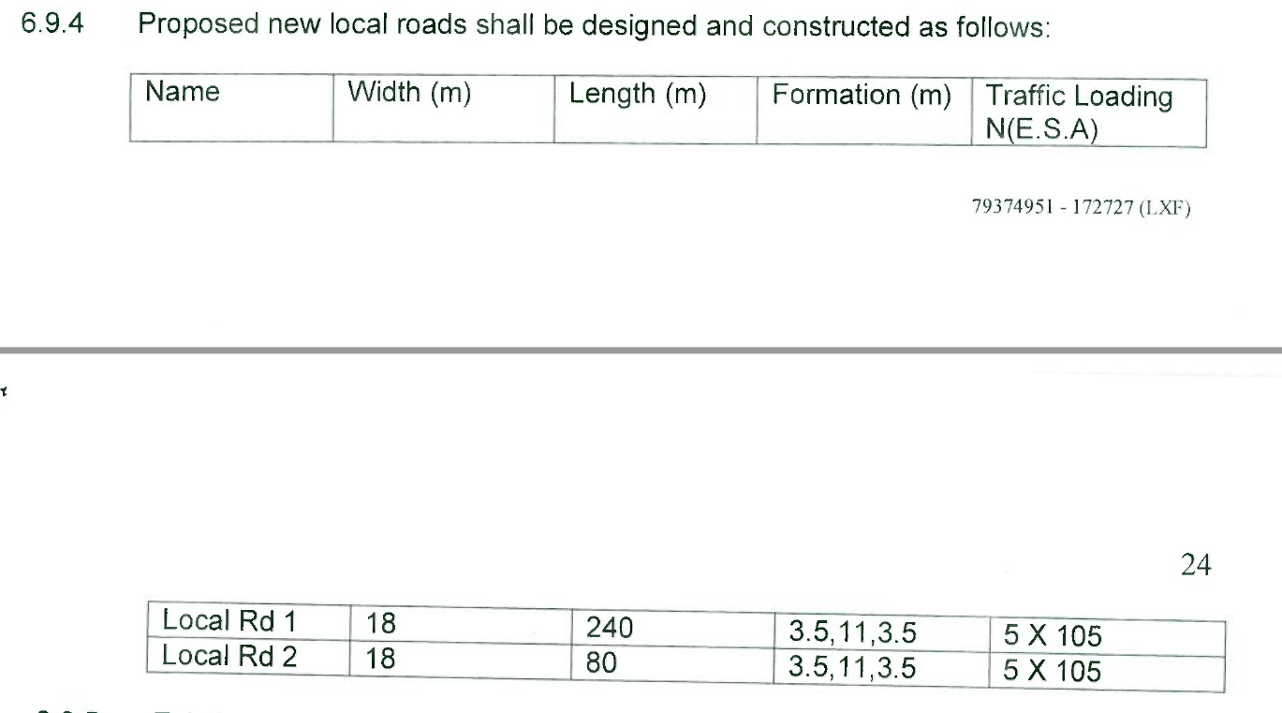

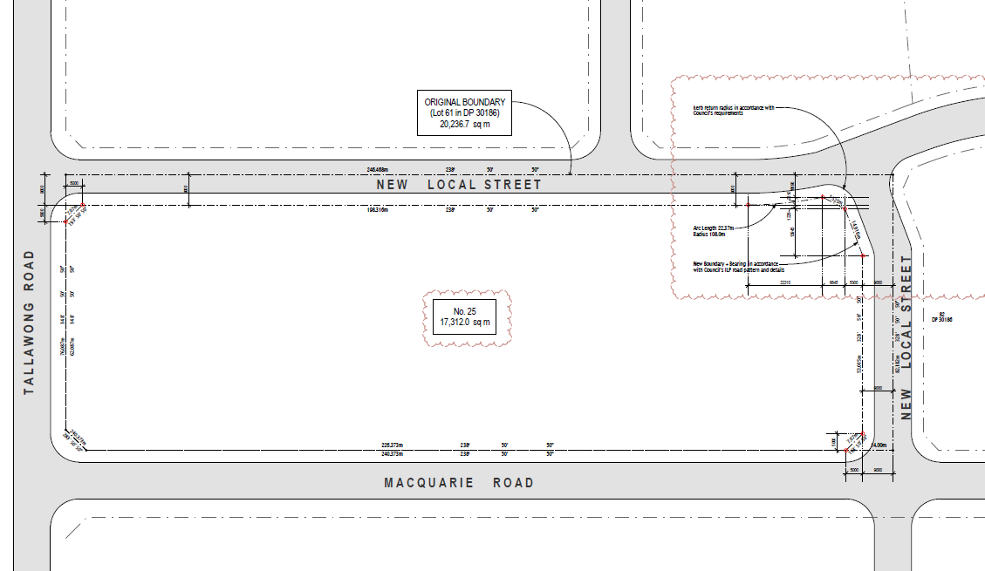

Figure 1 - Condition 6.9.4 and approved subdivision plan

The realignment of the new local road between 25 Macquarie Road and this site is demonstrated in Figure 2 below. The area identified in blue demonstrates the realignment of the half road. An enlarged intersection is accommodated on the Applicant’s land, with no impact on the approved DA at 25 Macquarie Road. It will require approval from Council’s Manager Access and Transport and the Local Traffic Committee for the configuration, line marking and signage arrangements.

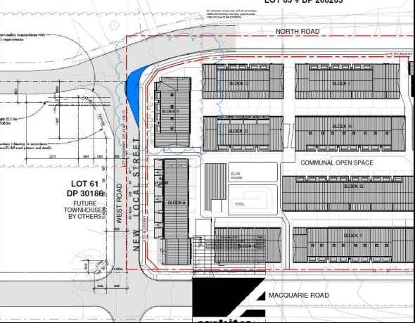

Figure 2 - Realignment of new local road between 25 Macquarie Road and subject site

External referrals

The Development Application was referred to the following external authorities for comment:
Authority | Comments
RMS | Acceptable subject to comments provided
RFS | Acceptable subject to conditions
Axicom | Acceptable subject to conditions
Transgrid | Acceptable
Sydney Water | Acceptable subject to conditions

Internal referrals

The Development Application was referred to the following internal sections of Council for comment:
Section | Comments
Building | Acceptable subject to conditions
Traffic | Acceptable subject to conditions
Development Engineers | Acceptable subject to conditions
Drainage Engineers | Acceptable subject to conditions
Waste | Acceptable subject to conditions
City Architect | Acceptable subject to conditions
Trees/Landscaping | Acceptable subject to conditions
Biodiversity | Acceptable subject to conditions
Environmental Health | Acceptable subject to conditions
Heritage | Acceptable subject to conditions

Conclusion

The proposed development has been assessed against all relevant matters and is considered to be satisfactory. It is considered that the likely impacts of the development have been satisfactorily addressed and that the proposal is in the public interest. The site is considered suitable for the proposed development subject to conditions.

Recommendation
- Uphold the Applicant’s Clause 4.6 written request to vary the height of buildings development standard in Clause 4.3 of State Environmental Planning Policy (Sydney Region Growth Centres) 2006, provided at attachment 7.
- Approve Development Application SPP-18-01547 for the reasons listed below and subject to the conditions listed in attachment 8:
  - The proposal is in the public interest.
  - The site is considered suitable for the proposed development.
  - The requested Clause 4.6 variation is acceptable given the particular circumstances of the application.

- Council officers notify the Applicant and submitter of the Panel’s decision.

_________________________
Kelly Coyne
Assistant Team Leader Development

_________________________
Alan Middlemiss
Acting Manager Development Assessment

_________________________
Glennys James PSM
Director Planning and Development

